**CSGY 6033 Algorithms Cheat Sheet**

Contents

Asymptotic Function Ordering 2

Equations 2

Big O: 2

Big Omega: 3

Theta: 3

Master Method: 3

Induction: 3

Linear Probing: 3

Quadratic Probing: 3

Summation: 3

Log N Formula: 3

Merge-Sort 4

Appendix 4

Summation Tricks 4

Logarithm Tricks 5

# Asymptotic Function Ordering

|  |  |  |  |
| --- | --- | --- | --- |
| # | Ex 1. | Ex 2. | Ex 3. |
| 1 | log(n) | log (n0.5) = (0.5) log(n) | log(n2) = 2*log(n) |
| 2 | n0.3 * log(n) |  |  |
| 3 | n * log n | n log (n2) = 2*n log n |  |
| 4 | n * (log n) 2 |  |  |
| 5 | n1.3­ = n * n3 |  |  |
| 6 | n2log n |  |  |
| 7 | 4n/3 = (41/3)n |  |  |
| 8 | 2n |  |  |
| 9 | 3n |  |  |
| 10 | n! |  |  |
| 11 | nn |  |  |

Asymptotically Function (increasing order)

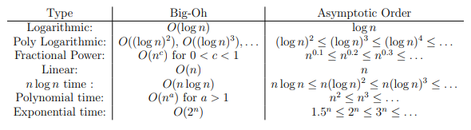

# Equations

Big O:Will give us an upper bound for function f(n) when n is very large/asymptotically. This is used extensively to describe the worst-case scenario for the number of operations used by an algorithm. The notation used in the definition is: O(g(n)) which is read “big-oh of g of n”

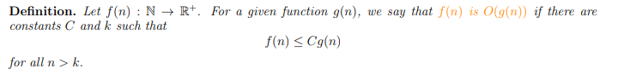



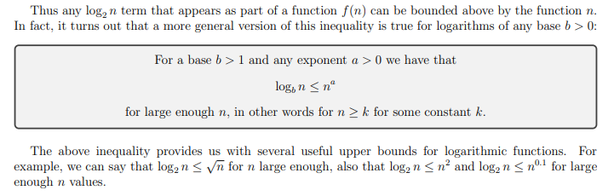

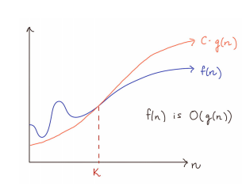

## Big Omega:

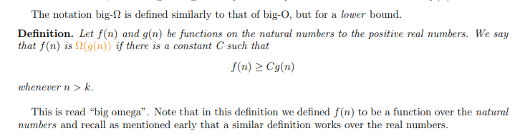

## Theta:



Master Method:the algorithm takes a problem of size n and calls itself on a problem of size . So as long as b > 1, it is working on a smaller problem size. These types of situations have the following equation for the run time:

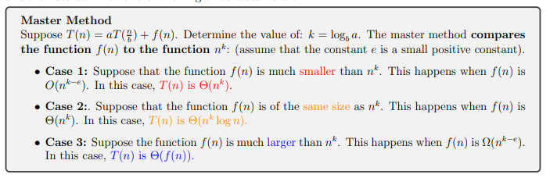

## Induction:

when induction, only reason it works is working out exactly what induction hypothesis is.

**Rules:** Must work out Big O exactly. If we do not get induction hypothesis exactly, doesn’t work out.

Linear Probing: h(k) + c1i

Quadratic Probing: h(k) + c1i + c2i^2

## Summation:

## Log N Formula:

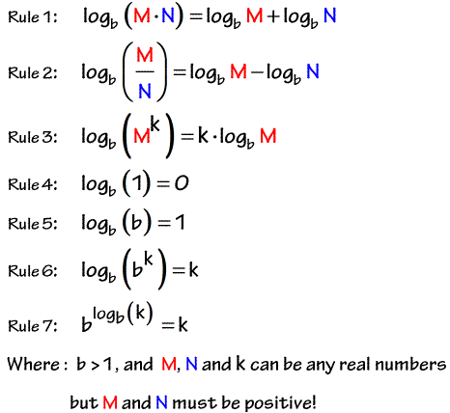

Merge-Sort sorts an array of n items using a divide-and-conquer approach. The three steps of merge-sort can be described as follows:

1. Divide the array of length n into two subsections of size n/2.
2. Conquer: Sort the two smaller sections using mergesort on each half.
3. Combine: Merge the two smaller sections together into one large sorted sequence

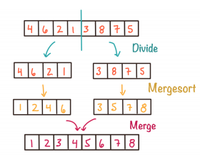

## Insertion-Sort

1. Start with sorted prefix of size 1 (sorted on left, unsorted on right)
2. Extend size of sorted prefix by 1
3. Repeat

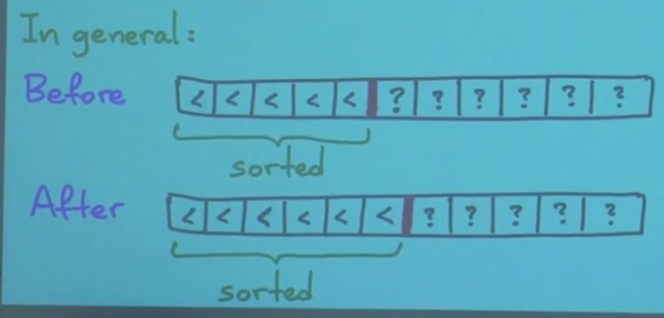

# Appendix

## Summation Tricks

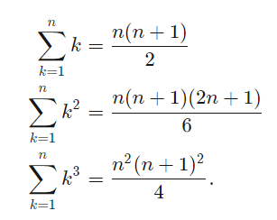

## Logarithm Tricks



